*Mockups for Bank*

**Login Page**

This page will be used for login by Manager as well as Customer

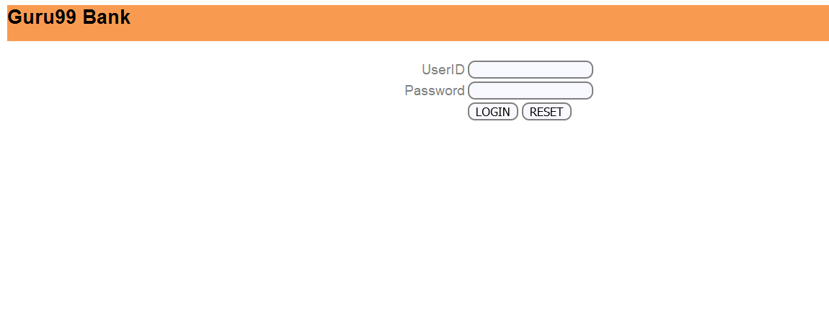

**Home Page**

*Manager*

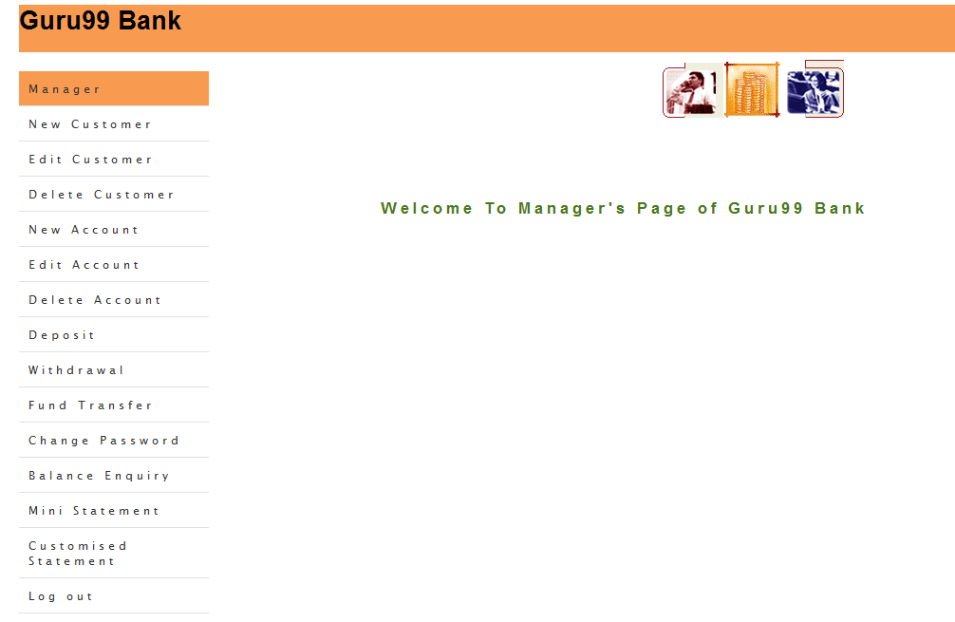

*Customer*

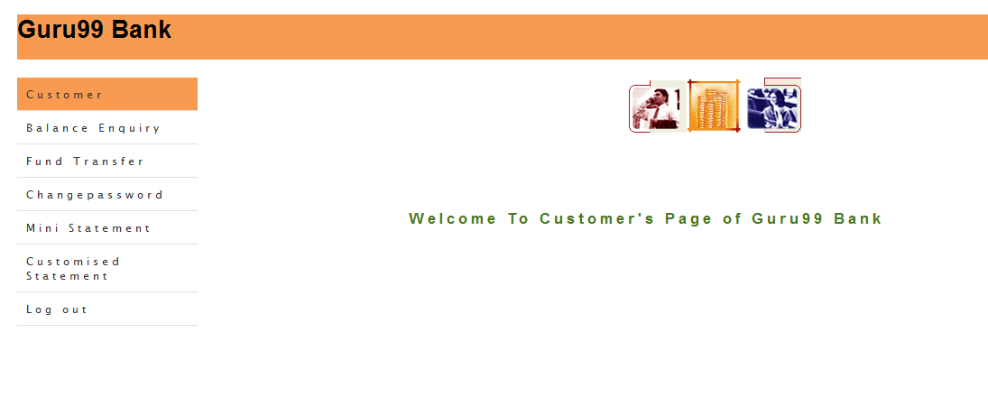

**Add Customer Functionality for Manager**

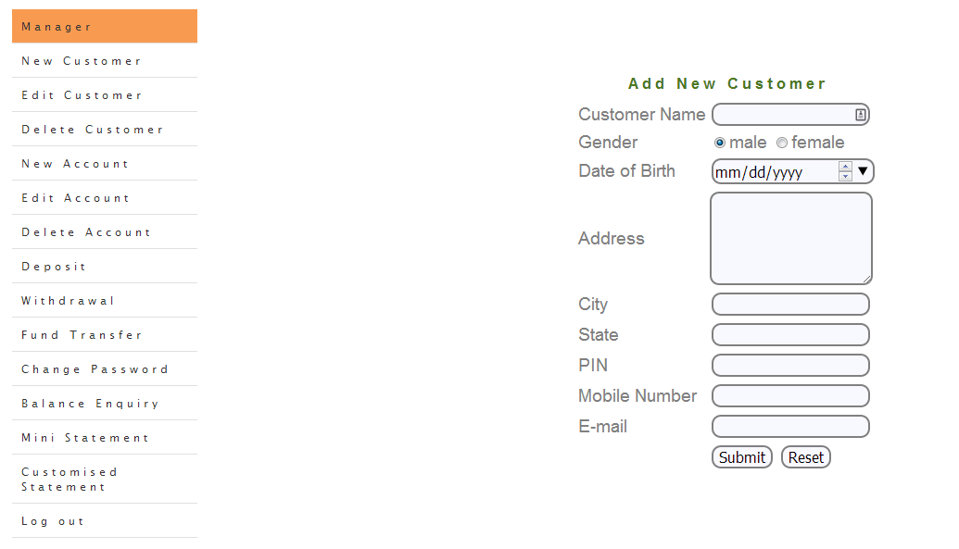

**Add Account Functionality for Manager**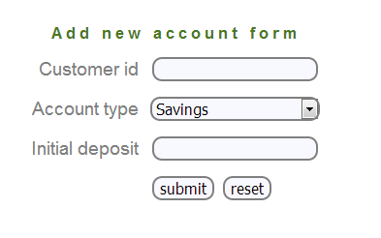

**Mini Statement Functionality for Manager/Customer**

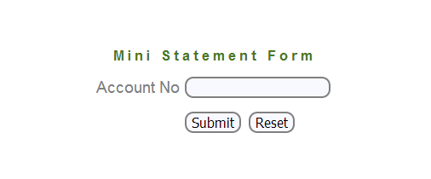

**Customized Statement for Manager/Customer**

